**Chapter 12**

Bottom of Form

Remember, changes to question templates won't automatically update quizzes that are already using those questions.

**Discussion 12.1: Your 8 AM Algorithm 1 pts**

[*Edit this Question*](https://colostate.instructure.com/courses/94768/question_banks/170481) [*Delete this Question*](https://colostate.instructure.com/courses/94768/question_banks/170481)

This post is not anonymous. The professor and participants can see the responses and the author.

What are the individual steps you take to solve the problem of attending class and arriving in time for the lectures? It is likely your solution will look similar to mine, but inevitably your routine has some unique distinctions. Do you hit the snooze? How many times? Etc. Feel free to describe as much or as little as you would like but be sure to list it out step-by-step as in the Professors Solution example.

[move/copy question to another bank](https://colostate.instructure.com/courses/94768/question_banks/170481)

**Question 12.1: Follow the Logic 1 pts**

[*Edit this Question*](https://colostate.instructure.com/courses/94768/question_banks/170481) [*Delete this Question*](https://colostate.instructure.com/courses/94768/question_banks/170481)

Let forecast = 56

The algorithm suggests that you wear __________ and __________.

**Correct Answer** longsleeve shirt, jeans

[move/copy question to another bank](https://colostate.instructure.com/courses/94768/question_banks/170481)

**Question 12.2: Find the bug 1 pts**

[*Edit this Question*](https://colostate.instructure.com/courses/94768/question_banks/170481) [*Delete this Question*](https://colostate.instructure.com/courses/94768/question_banks/170481)

For the next question, consider the following algorithm for determining where to go out to eat with a boyfriend or girlfriend. Find the bug in the algorithm. What is the line number that contains the bug?

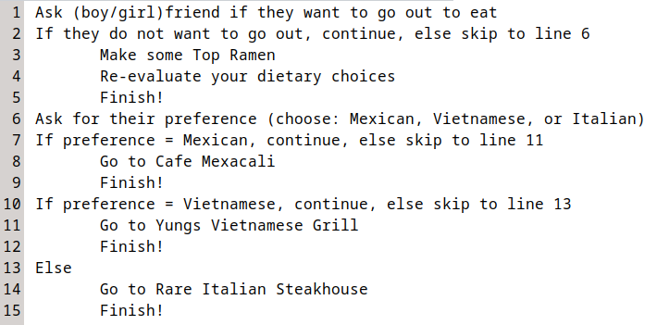

**Correct Answer** 7

[move/copy question to another bank](https://colostate.instructure.com/courses/94768/question_banks/170481)

**Question 12.3: Exam studying algorithm 1 pts**

[*Edit this Question*](https://colostate.instructure.com/courses/94768/question_banks/170481) [*Delete this Question*](https://colostate.instructure.com/courses/94768/question_banks/170481)

Consider that a student designs an algorithm that informs them how much they should be studying each school day for an exam. The algorithm makes a decision about how much the student should study based on how far away the exam is. The student "runs" the algorithm once a day in the morning. Consider that the exam is 9 days away. How much time does the student spend studying according to this algorithm?

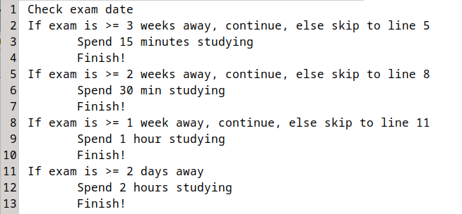

A. 15 minutes

B. 30 minutes

C. 1 hour

D. 2 hours

**Correct Answer** C

[move/copy question to another bank](https://colostate.instructure.com/courses/94768/question_banks/170481)

**Discussion 12.2: Algorithms in life 1 pts**

[*Edit this Question*](https://colostate.instructure.com/courses/94768/question_banks/170481) [*Delete this Question*](https://colostate.instructure.com/courses/94768/question_banks/170481)

This post is not anonymous. The professor and participants can see the responses and the author.

What is an algorithm you use in everyday life that is unique to yourself? Perhaps you are a gifted gardener and know exactly how to prune apple trees? Are you into repairing cars and know the best procedure to follow to diagnose and replace an alternator? I am willing to bet that there is something that you know how to do that a lot of your classmates would not understand (it doesn't matter how nerdy or weird it is). Think about an algorithm that only you would know (or very few of your classmates), and explain it "algorithmically" as either a flowchart OR pseudo-code. The only requirement is that it should have some decisions to make and should contain no bugs.

My suggestion is to avoid recipes, they are kind of boring and aren't really unique TO YOU. If you decide to do a flowchart, you can upload an image of your flowchart to this discussion for credit.

[move/copy question to another bank](https://colostate.instructure.com/courses/94768/question_banks/170481)

**Personal Reflection - Chapter 12 1 pts**

[*Edit this Question*](https://colostate.instructure.com/courses/94768/question_banks/170481) [*Delete this Question*](https://colostate.instructure.com/courses/94768/question_banks/170481)

This is a completely anonymous submission. The professor will be able to see the responses but the responses will not be attributed to an author. Your participation is required.

What do you think about the content of this chapter? Did you learn anything new? Do you need to do some more practice? What do you think about the other chart types (that I said were garbage)? Do you agree / disagree? Do some personal reflection.

[move/copy question to another bank](https://colostate.instructure.com/courses/94768/question_banks/170481)

**Request for Feedback - Chapter 12 1 pts**

[*Edit this Question*](https://colostate.instructure.com/courses/94768/question_banks/170481) [*Delete this Question*](https://colostate.instructure.com/courses/94768/question_banks/170481)

This is a completely anonymous submission. The professor will be able to see the responses but the responses will not be attributed to an author. Your participation is required.

What did you think of this chapter? Anything stand out as exceptionally good? Anything that you would like to see differently? Any feedback is appreciated.

[move/copy question to another bank](https://colostate.instructure.com/courses/94768/question_banks/170481)